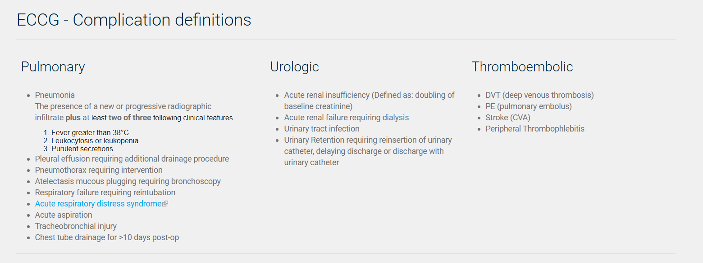
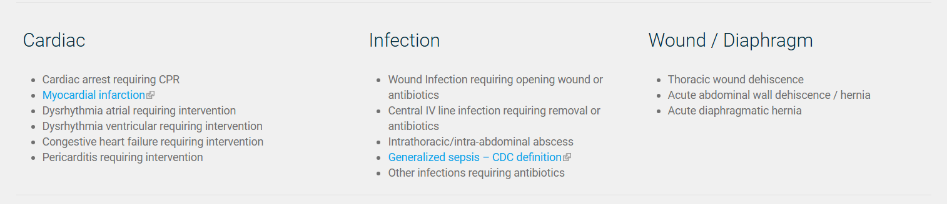

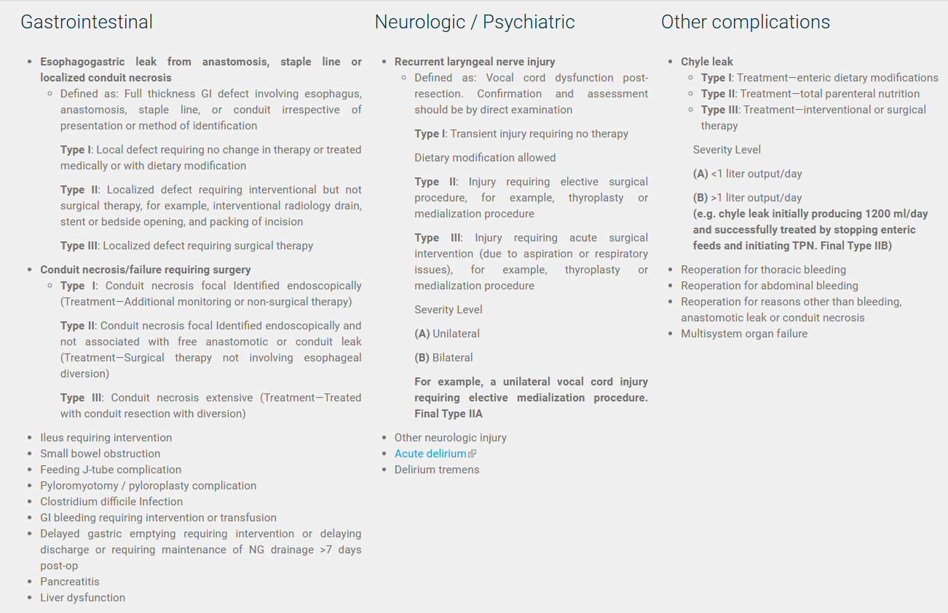

Acute respiratory distress syndrome: https://jamanetwork.com/journals/jama/article-abstract/1160659
Myocardial infraction: http://ije.oxfordjournals.org/content/40/1/139.full
Sepsis: Sepsis should be defined as life-threatening organ dysfunction caused by a dysregulated host response to infection. For clinical operationalization, organ dysfunction can be represented by an increase in the Sequential [Sepsis-related] Organ Failure Assessment (SOFA) score of 2 points or more, which is associated with an in-hospital mortality greater than 10%. The Third International Consensus Definitions for Sepsis and Septic Shock (Sepsis-3) - PubMed

Delirium: The criteria from the 'Diagnostic and Statistical Manual of Mental Disorders' 6 [DSM IV] (1994) describe delirium as:
- disturbance of consciousness (i.e., reduced clarity of awareness of the environment) with reduced ability to focus, sustain, or shift attention.
- a change in cognition (such as memory deficit, disorientation, language disturbance) or the development of a perceptual disturbance that is not better accounted for by a pre-existing, established, or evolving dementia.
- the disturbance develops over a short period of time (usually hours to days) and tends to fluctuate during the course of the day.
- there is evidence from the history, physical examination, and laboratory findings that:
- the disturbance is caused by the direct physiological consequences of a general medical condition,
- the symptoms in criterion (i) developed during substance intoxication, or during or shortly after, a withdrawal 18 syndrome, or
- the delirium has more than one aetiology”.

